TECHNOMATES

HEALTH MONITORING

SYSTEM

TEAM MEMBERS-

1. **AKASH AGARWAL**
2. **SRASHTI KATIYAR**
3. **GUNJAN VERMA**
4. **SUSHIL SHUKLA**
5. **MEGHA SINGH**

REAL TIME EMBEDED

TELE-HEATH MONITORING SYSTEM

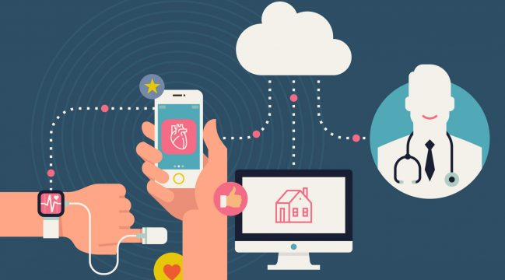

1. **The mode of delivering health care services and public health via information and communication technologies to facilitate the diagnosis, consultation, treatment, education, care management, and self-management of a patient's health care while the patient is at the originating site and the health care provider is at a distant site. Telehealth facilitates patient self-management and caregiver support for patients and includes synchronous interactions and asynchronous store and forward transfers.**
2. **The use of electronic information and telecommunications technologies to support long-distance clinical health care, patient and professional health-related education, public health and health administration is called tele-health monitoring system.**

**USES OF TELE-HEALTH MONITORING-**

1. **Health care and public health practice and education supported by mobile communication devices such as cell phones, tablet computers, and PDAs. Applications can range from targeted text messages that promote healthy behavior to wide-scale alerts about disease outbreak**.
2. 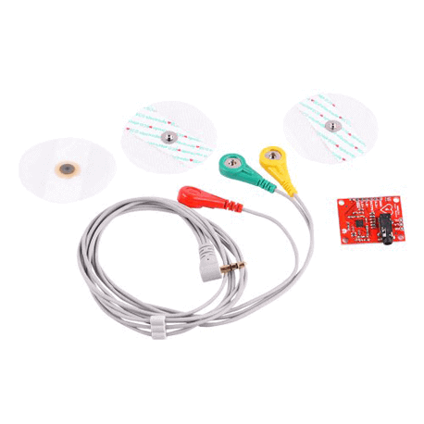**Personal health and medical data collection from an individual in one location via electronic communication technologies, which is transmitted to a provider (sometimes via a data processing service) in a different location for use in care and related support**.

**COMPONENTS REQUIRED** –

* **AD 8232 Electrocardiogram Sensor**

**(ECG)**

* **HEART BEAT SENSOR**

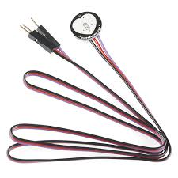

* **BODY TEMPERATURE SENSOR**
* **ARDUINO UNO (Atmega328P MICROCONTROLER )**

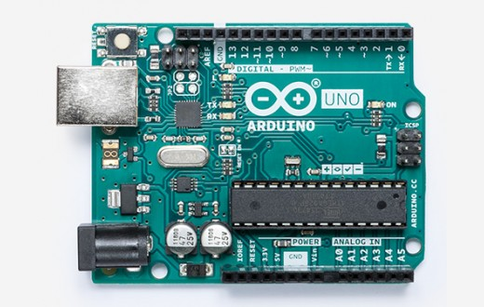

* **9V DC SUPPLY + BATTERY**
* **BLUETOOTH MODULE (HC-05)**
* **CONNECTING WIRES**
* **16*2 LCD DISPLAY + I2C MODULE**
* **COADING ON ARDUINO IDLE**